











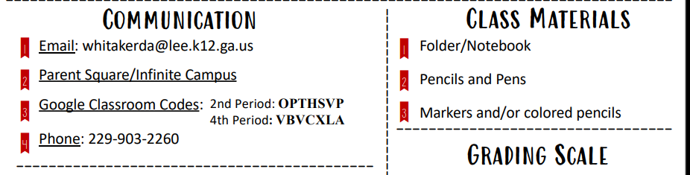





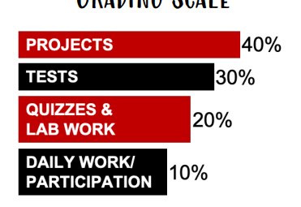













**Contemporary Issues in Education Syllabus Student & Parent Acknowledgement**

I have read and understood the syllabus in its entirety. I have asked questions about anything for which I want clarification.

Student’s Name: ___________________________________

Student’s Signature: ________________________________

Guardian’s Signature: _______________________________

Guardian’s email address: ___________________________

Please circle your preferred method of contact: email phone call note

*\*I make every effort to respond to email within 24 hours, please follow up with a phone call to the school if you do not hear from me.\**

Please list any additional information you would like me to know about your student so that he/she may have the best possible year. ____________________________________________________________________________________________________________________________________________________________________________________________________________________________________________________________________________________

